  - Honors Biology Chapter 17 Section 1 Student Notes
The History of Classification
Early Systems of Classification
- Biologists use a system of classification to organize information about the diversity of living things.
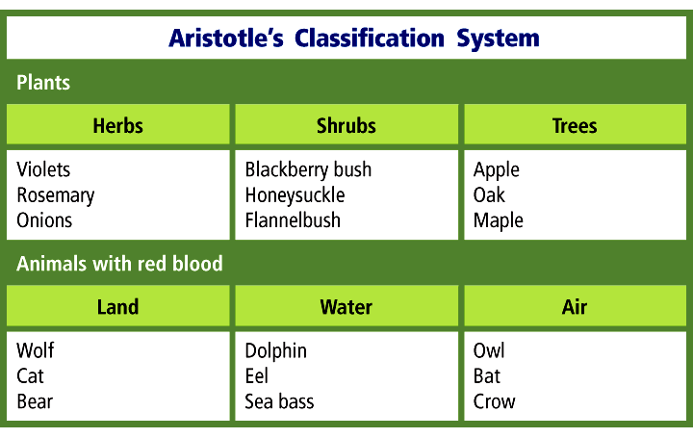
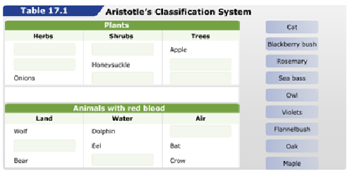
Aristotle’s System
- More than 2000 years ago, Aristotle developed the first widely accepted system of biological classification.
- Aristotle classified organisms as either animals or plants.
- Animals were classified according to the presence or absence of “red blood.”
- Animals were further grouped according to their habitats and morphology.
- Plants were classified by average size and structure as trees, shrubs, or herbs.
Linnaeus’s System
- Linnaeus’s system of classification was the first formal system of taxonomy.
Binomial Nomenclature
- Linnaeus’s method of naming organisms, called binomial nomenclature, gives each species a scientific name with two parts.
- The first part is the genus name, and the second part is the specific epithet, or specific name, that identifies the species.
- Biologists use scientific names for species because common names vary in their use.
- When writing a scientific name, scientists use these rules:
  - The first letter of the genus name always is capitalized, but the rest of the genus name and all letters of the specific epithet are lowercase.
  - If a scientific name is written in a printed book or magazine, it should be italicized.
  - When a scientific name is written by hand, both parts of the name should be underlined.
  - After the scientific name has been written completely, the genus name will be abbreviated to the first letter in later appearances (e.g., C. cardinalis).
Taxonomic Categories
- The taxonomic categories used by scientists are part of a nested-hierarchal system.
- Each category is contained within another, and they are arranged from broadest to most specific.
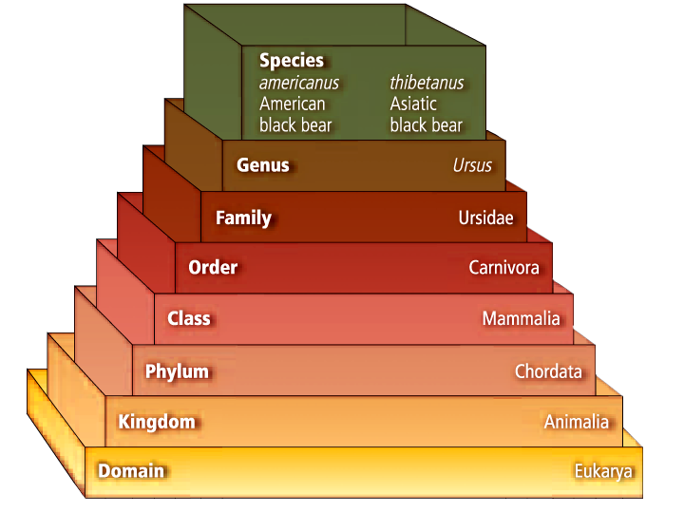

Species and Genus
- A named group of organisms is called a taxa.
- A genus (plural, genera) is a group of species that are closely related and share a common ancestor.
Family
- A family is the next higher taxon, consisting of similar, related genera.
Higher Taxa
- An order contains related families.
- A class contains related orders.
- A phylum or division contains related classes.
- The taxon of related phyla or divisions is a kingdom.
- The domain is the broadest of all the taxa and contains one or more kingdoms.

