Honors Biology Chapter 10 Study Guide
  - Vocabulary

Heredity
Genetics
Trait
Gamete
Pollination
True Breeding
Fertilization
Hybrid
Allele
Dominant
Recessive
Law of segregation
Phenotype
Genotype
Homozygous
Heterozygous
Law of independent assortment
Diploid
Haploid
Homologous chromosomes
Meiosis
Sperm
Egg
Zygote
Sexual reproduction
Crossing over
Genetic recombination
Nondisjunction

  - Concepts
How many chromosomes does the human body have?
How many chromosomes do you get from each parent?
What are three characteristics of homologous chromosomes?
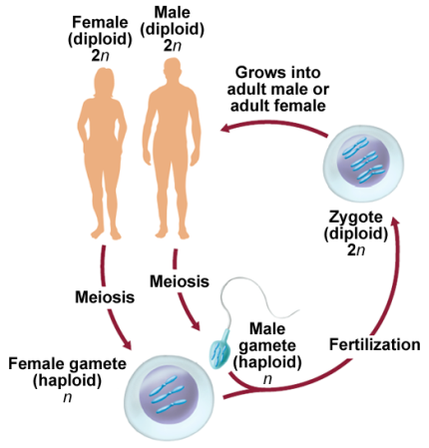
What does meiosis produce?
Stages of meiosis
Why is meiosis important? ( 3 reasons)
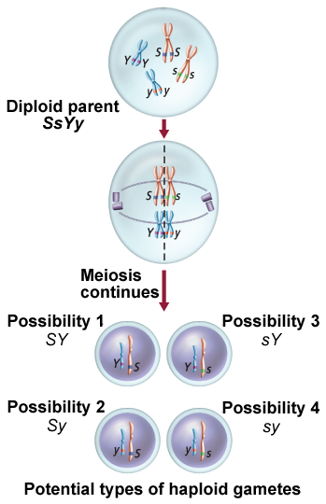
What is the difference between sexual and asexual reproduction?
Gregor Mendel
- Biography
- Describe his pea plant experiment
- Why did he pick pea plants?
P, F1, & F2 Generations
What are five traits Mendel used to study pea plants?
Describe Mendel’s law of segregation?
What is a monohybrid cross?
Fill in the following chart
Symbol | Genotype | Phenotype
BB
Bb
bb

Who was Reginald Punnet?
Review Punnet Square Worksheets

