  - Chapter 9 Section 1 Student Notes
Ratio of Surface Area to Volume
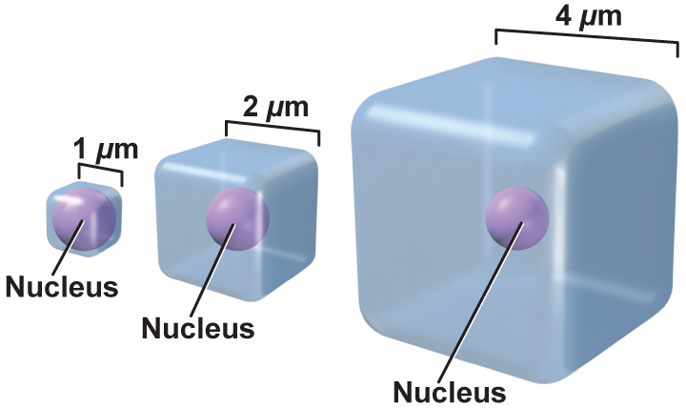
- As the cell grows, its volume increases much more rapidly than the surface area.
- The cell might have difficulty supplying nutrients and expelling enough waste products.
Transport of Substances
- Substances move by diffusion or by motor proteins.
- Diffusion over large distances is slow and inefficient.
- Small cells maintain more efficient transport systems.
Cellular Communications
- The need for signaling proteins to move throughout the cell also limits cell size.
- Cell size affects the ability of the cell to communicate instructions for cellular functions.
The Cell Cycle
- Cell division prevents the cell from becoming too large.
- It also is the way the cell reproduces so that you grow and heal certain injuries.
- Cells reproduce by a cycle of growing and dividing called the cell cycle.
- Interphase is the stage during which the cell grows, carries out cellular functions, and replicates.
- Mitosis is the stage of the cell cycle during which the cell’s nucleus and nuclear material divide.
- Cytokinesis is the method by which a cell’s cytoplasm divides, creating a new cell.

The Stages of Interphase
- The first stage of interphase, G₁
    - The cell is growing, carrying out normal cell functions, and preparing to replicate DNA.
- The second stage of interphase, S
    - The cell copies its DNA in preparation for cell division.
- The third stage of interphase, G₂
    - The cell prepares for the division of its nucleus.

