  - Chapter 7 Section 4 Student Notes
Facilitated Diffusion
- Movement of materials across the plasma membrane using proteins
Channel Proteins
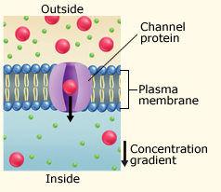

Carrier Proteins
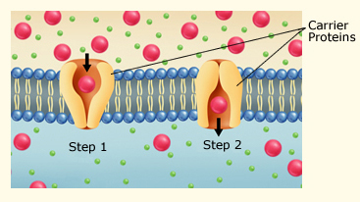

Osmosis
- Diffusion of water across a selectively permeable membrane

Three Types of Osmotic Solutions

- Isotonic
- Hypotonic
- Hypertonic

Isotonic Solution
- Water and dissolved substances diffuse into and out of the cell at the same rate.
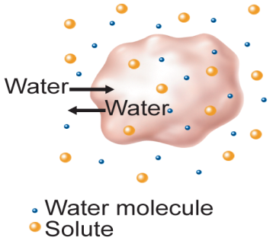

Hypotonic Solution
- Solute concentration is higher inside the cell.
- Water diffuses into the cell.
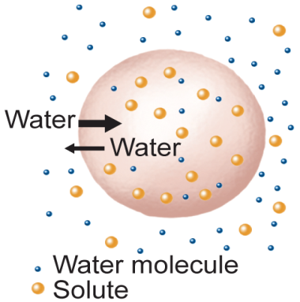

Hypertonic Solution
- Solute concentration is higher outside the cell.
- Water diffuses out of the cell.
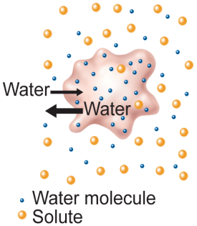

Active Transport
- Movement of particles across the cell membrane using energy
Endocytosis
- Process by which the cell surrounds and takes particles into the cell
Exocytosis
- Secretion of material out of the plasma membrane

