  - Biology Chapter 21Student Notes
Plant Evolution and Adaptations
When scientists compare present-day plants and present-day green algae, they find the following common characteristics:
  - cell walls composed of cellulose
  - cell division that includes the formation of a cell plate
  - the same type of chlorophyll used in photosynthesis
  - similar genes for ribosomal RNA
  - food stored as starch
  - the same types of enzymes in cellular vesicles
Cuticle
- Helps prevent the evaporation of water from plant tissues
- Acts as a barrier to invading microorganisms
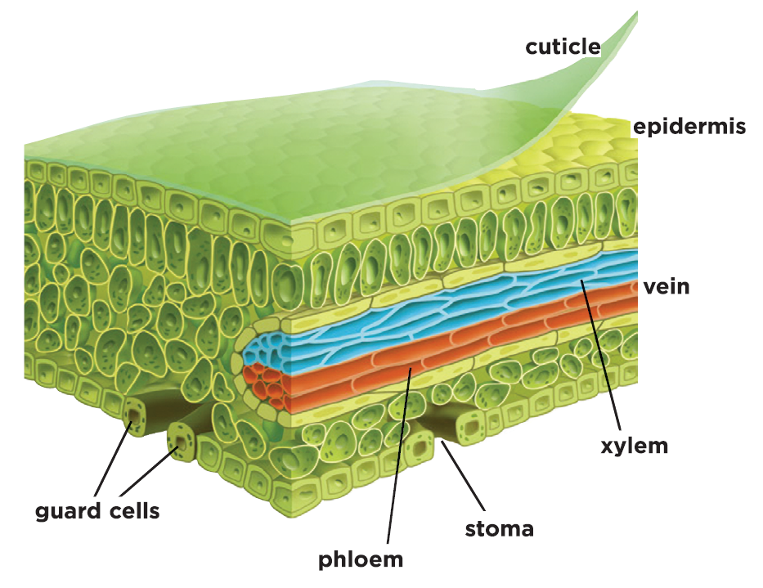
Stomata
- Adaptations that enable the exchange of gases even with the presence of a cuticle on a plant
- Openings in the outer cell layer of leaves and some stems

Vascular Tissues
- Vascular tissue enables faster movement of substances than by osmosis and diffusion, and over greater distances.
- Vascular tissue provides support and structure, so vascular plants can grow larger than nonvascular plants.
Seeds
- A plant structure that contains an embryo, contains nutrients for the embryo, and is covered with a protective coat
- These features enable seeds to survive harsh environmental conditions and then sprout when favorable conditions exist.
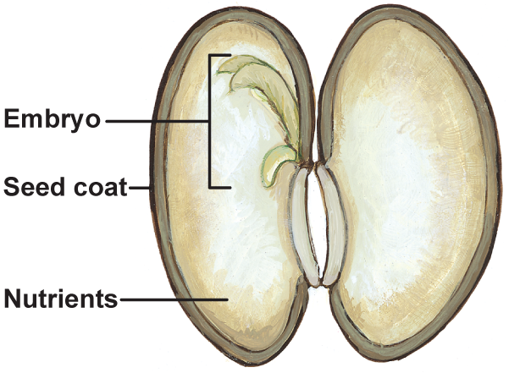

Alternation of Generations
- Gametophyte generation produces gametes.
- Sporophyte generation produces spores that can grow to form the next gametophyte generation.
- During plant evolution, the trend was from dominant gametophytes to dominant sporophytes that contain vascular tissue.
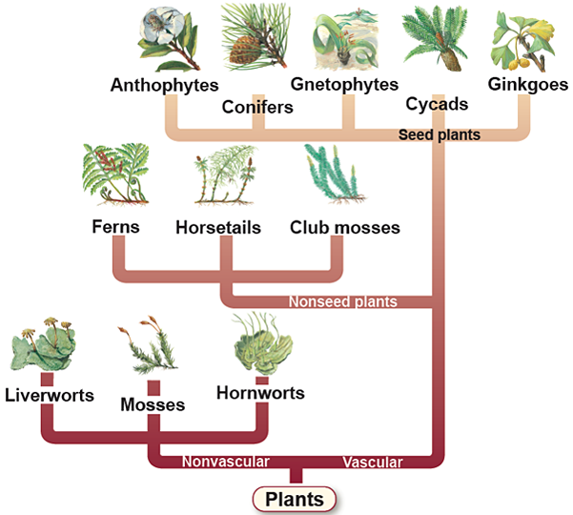
Plant Classification
- Nonvascular plants lack specialized transport tissues.
- Seedless Vascular Plants
- Seed-producing Vascular Plants

