Biology Chapter 21, 22, 23

Study Guide
  - Chapter 21

Characteristics of plants
Adaptation of plants
Cuticle
Function of the cuticle
Stoma
Function of the stoma
Epidermis
Vein
Xylem
Phloem
Guard cells

Label the cross section of a plant
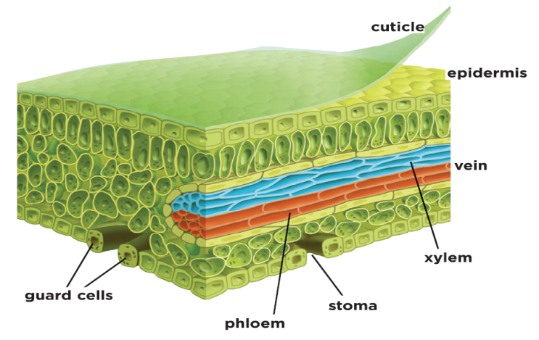

Vascular tissue
Seed
Seed coat
Nutrients of a seed

Label a seed
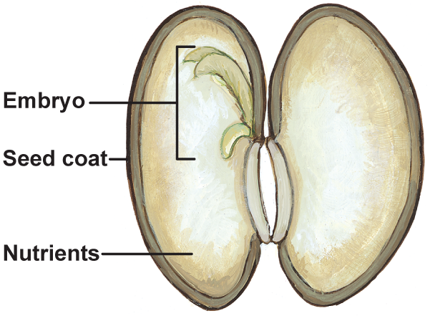

Gametophyte
Sporophyte
Plant categories & sub categories (define)

  - Chapter 22

Three types of plant cells (define)
Functions of types of plant cells
Plant tissue (define)
Meristem
Root hairs
Vessel elements
Sieve-tube member
Companion cells
Roots
Structure of root (root cap, cortex, endodermis)
Types of roots (define)
Stem structure and function (monocot & dicot)
Leaf structure (blade , petiole, palisades mesophyll layer, spongy layer)
Leaf type (simple and compound)
Leaf modifications
Label the leaf structure

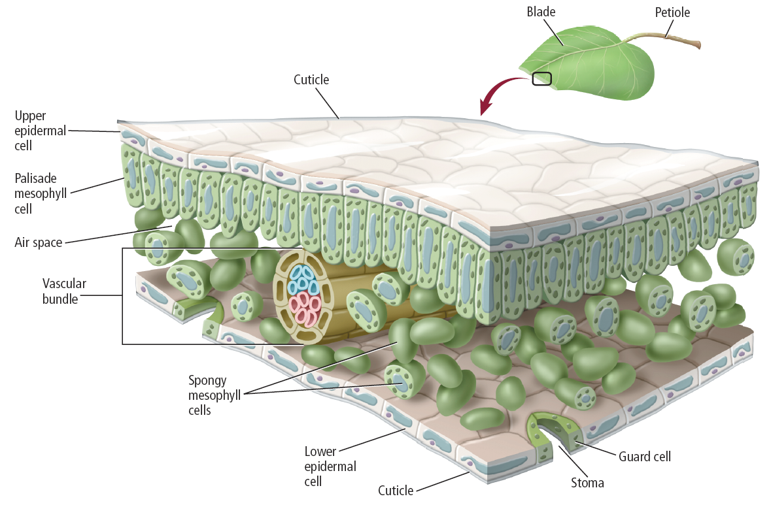

  - Chapter 23
Pollination
Flower organs (define)
Label organs on a flower
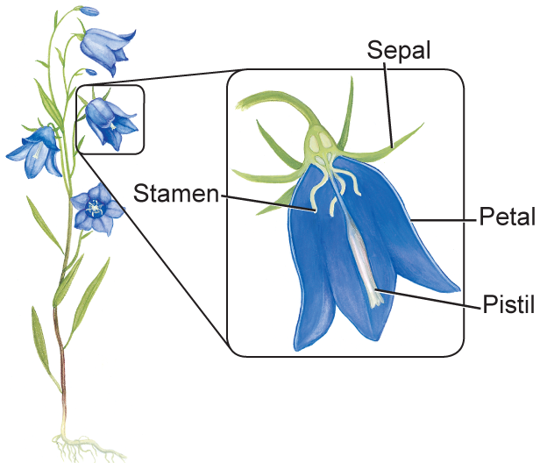
Flower adaptations
Complete flower
Incomplete flower
Perfect flower
Imperfect flower
Monocots
Dicots
Pollination Mechanisms

