Honors Biology Chapter 9 Study Guide
  - Vocabulary

Cell cycle
Interphase
Mitosis
Cytokinesis
Chromosome
Chromatin
Prophase
Sister chromatid
Centromere
Spindle apparatus
Metaphase
Anaphase
Telophase
Cyclin
P53
Cancer
Carcinogen
Apoptosis
Stem cell

  - Concepts
Ratio of Surface Area to Volume
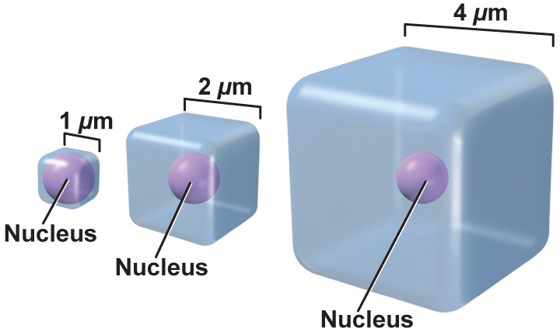
Transport of substances
How do cell communicate?
Parts of the cell cycle
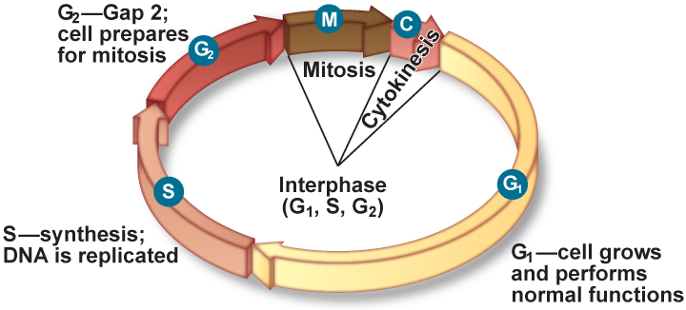
What are the stages of interphase? Explain each.
Draw and label a chromosome.
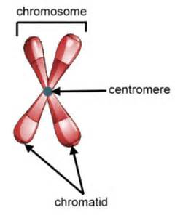

What are the parts of mitosis?
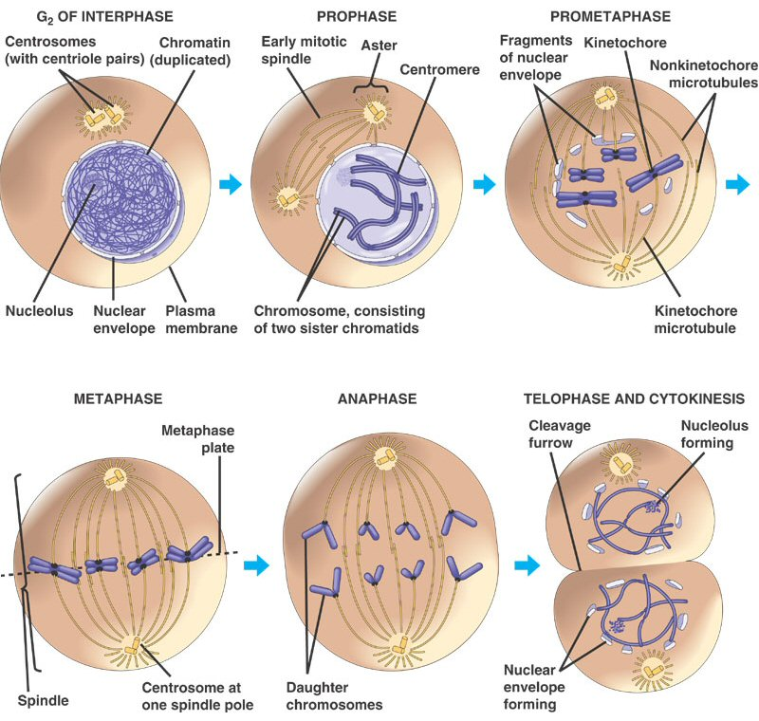
What is the difference between cytokines in animal and plant cells?
What are three functions of mitosis?
What are you things that can control the cell cycle?
What are the checkpoints in the cell cycle? Describe each.
What are some causes of cancer?
What is the difference between adult and embryonic stem cells?

