Honors Biology Chapter 23 Student Notes

Pollination
- Pollination occurs when the pollen grain from one species of a plant lands on the female reproductive structure of a plant of the same species.
- The pollen grain is trapped in a sticky substance called the pollen drop
Flower Organs
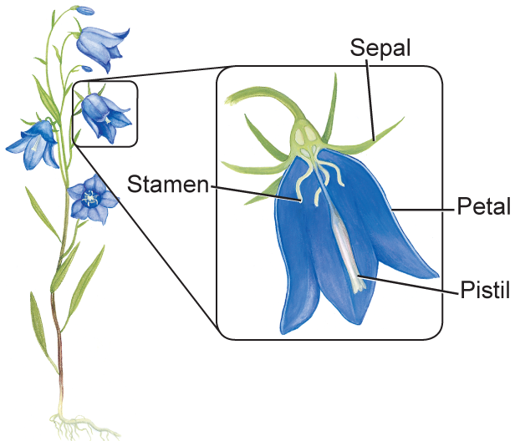
- Flowers are the reproductive structures.
- Flowers have several organs that provide protection or support, or are involved in the reproductive process.
- There are basically four structures—sepals, petals, stamen, and pistils.
- Sepals may be green and look like leaves and petals.
- Petals attract animal pollinators and provide a landing pad.
- Sepals and petals open and close to protect the reproductive parts of the flower.
- Most flowers have several stamen—the male reproductive organ—surrounding the central part of the flower.
- The filament stalk supports the anther, which contains the pollen grains.
Flower Adaptations
- Structural differences
- Flowers that have sepals, petals, stamens, and one or more pistils are called complete flowers.
- If a flower is missing one or more of these organs, it is an incomplete flower.
- Flowers that have both stamens and pistils are called perfect flowers.
- An imperfect flower has either functional stamens or pistils.
- The number of flower organs distinguishes dicots and eudicots from monocots.
- Monocots generally have multiples of three.
- When the petal number is a multiple of four or five, the plant is either a dicot or a eudicot.
- The number of other organs often is the same multiple of three, four, or five.
Pollination Mechanisms
- Flower adaptations that relate to pollination include flower size, shape, color, and petal arrangements.
  - Animal pollination
  - Wind pollination
  - Self pollination

