  - Honors Biology Chapter 22 Part 2 Student Notes
Roots
- The root is usually the first structure to grow out of the seed when it sprouts.
- Roots take in water and dissolved minerals that are transported to the rest of the plant.
- Functions:
  - Take in water & dissolve minerals
  - Anchor the plant
  - Support plant against effects of gravity, extreme wind, and moving water.
Root Structure and Growth
- The tip of a root is covered by the root cap-protect root tissue as root grows (has parenchyma cells).
- The layer below the epidermal layer is the cortex-made up of ground tissue (has parenchyma cells).
- The layer of cells at the inner boundary of the cortex is the endodermis.
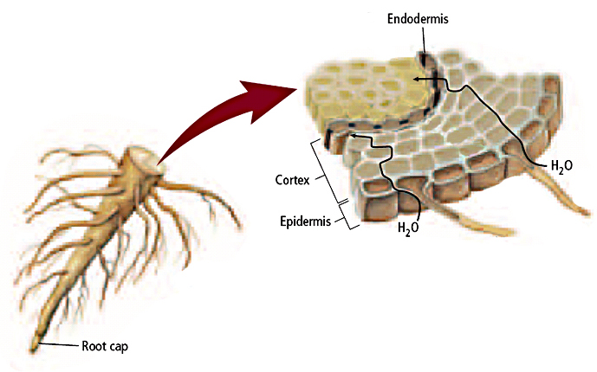

Types of Roots
- Taproot system
- Consists of a thick root with a few smaller, lateral-branching roots
- Ex: raddish. Beets, poison ivy
- Functions:
  - Anchor plants
  - Store food and water

- Fibrous root system
  - Numerous branching roots that are about the same size and grow from a central point
  - Ex: sweet patatoes
  - Functions
    - Anchor plants
    - Absorb a lot of water rapidly

- Modified roots
  - Huge water storage roots
  - Help supply oxygen

- Adventitious roots
  - Form where roots do not normally grow.
  - Support branches (ex: trunks)

Stem Structure and Function
- The main function of a plant’s stem is support of a plant’s leaves and reproductive structures.
- Transport water and dissolved substances
- Stores food and water
Examples: Monots
Dicots
Leaf Structure
- A flattened surface called a blade has a large surface area for photosynthesis.
- The blade may be attached to the stem by a petiole.
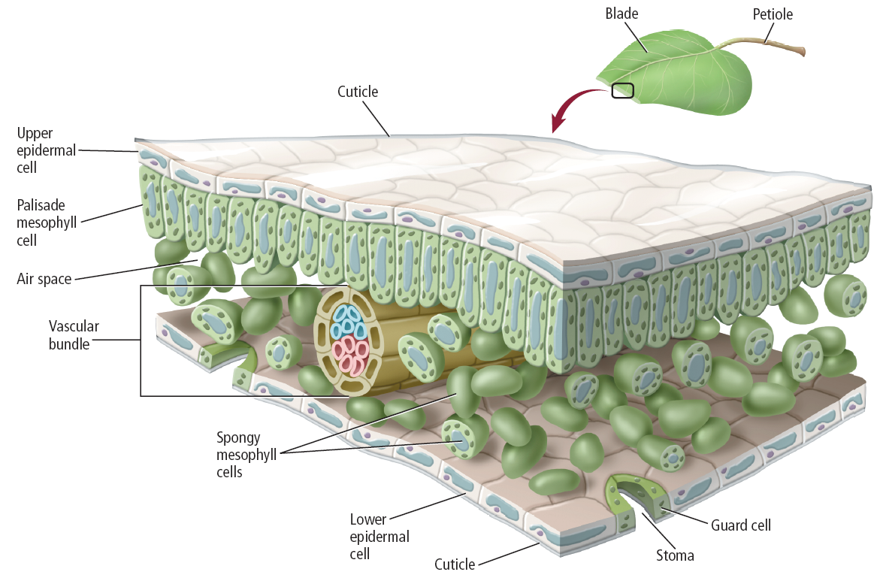
- The internal structure of most leaves is well-adapted for photosynthesis.
- Tightly packed cells directly below a leaf’s upper epidermis contain many chloroplasts and make up the tissue called the palisade mesophyll.
- Below the palisade mesophyll is the spongy mesophyll.
- Spongy layer =irregularly shaped, loosely packed cells w/spaces
  - Cells contain some chloroplasts
  - Oxygen, carbon dioxide and water move through the spaces
- Simple leaf – blades are not divided into 2 or more smaller parts
- Compound leaf – blade is divided into 2 or more smaller parts called leaflets.
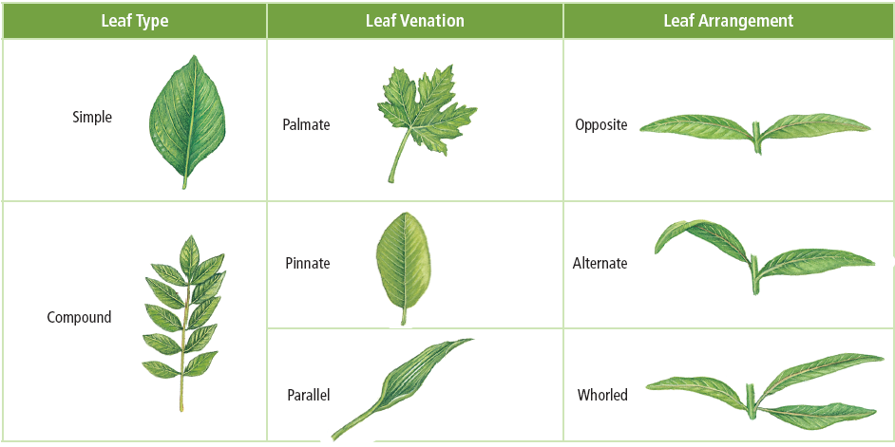
Leaf Modifications
- Spine – water loss and protection
- Sticky substances – trap insects
- Toxic chemicals – discourage organisms from touching them

