Honors Biology Chapter 17 & 18

Review Sheet

Chapter 17

Aritotle’s classification system
Carl Linnaeus – binomial nomenclature
Taxonomy
What are the four rules to writing a scientific name?
List and define the taxonomic categories
Taxa
Typological Species Concept
Biological Species Concept
Phylogenic Species Concept
Phylogeny
Characters
Morphological Characters
Cladistics
Cladogram
Three domains
Six kingdoms – characteristics

Chapter 18

Bacteria
Characteristics of bacteria
3 types of Archae
Differences between archae and bacteria

Prokaryotic structure
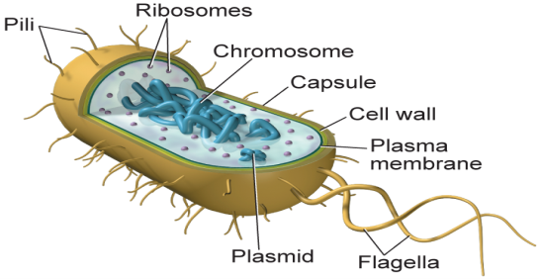

Function of ribosomes
Chromosome of bacteria
4 functions of a capsule
Cell wall
Flagella
Plasmid
Pili
2 functions of pili
3 shapes of bacteria
Binary fission
Conjugation
4 types of bacteria
Endospores
Mutations of bacteria
Food and medicine with bacteria
Disease causing bacteria
Virus
Origin of a virus
Viral infection
Lytic cycle
Lysogenic cycle
Retrovirus

