Honors Biology

Chapter 14 & 15 Study Guide

Chapter 14

How old is Earth?

How was the atmosphere made?

What are the gases in the atmosphere?

What gas is the most abundant in our atmosphere?

Categories of fossil types

Steps for the formation of fossils

Types of rocks

Fossil

Paleontologist

Relative dating

Law of superposition

Radiometric dating

Half-life

Geological time scale

Epoch

Period

Era

Eon

Precambrian

Paleozoic era

Mesozoic era

Plate tectonics

Cenozoic era

Spontaneous generation

Francesco Redi & his experiment

Theory of biogenesis

Louis Pasteur & his experiment

Stanley Miller and Harold Urey & their experiment

Method of making proteins

What were the first cells according to scientists?

What did cyanobacteria produce?

The Endosymbiont Theory

What was the first coding system?

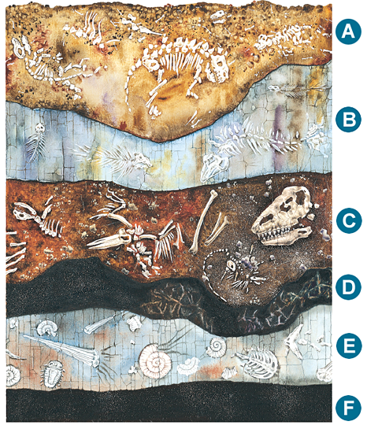

Chapter 15

HMS Beagle

Charles Darwin

Galapagos Island

Artificial selection

Natural selection

Evolution

The origin of species

Fossil record

Derived trait

Ancestral trait

Homologous structure

Vestigial structure

Analogous structure

Embryo

Biogeography

Fitness

Camouflage

Mimicry

Types of adaptation

Consequences of adaptation