  - Honors Biology Chapter 10 Section 1 Student Notes
  - Chromosomes and Chromosome Number
- Human body cells have 46 chromosomes
- Each parent contributes 23 chromosomes
- Homologous chromosomes—one of two paired chromosomes, one from each parent
- Same length
- Same centromere position
- Carry genes that control the same inherited traits
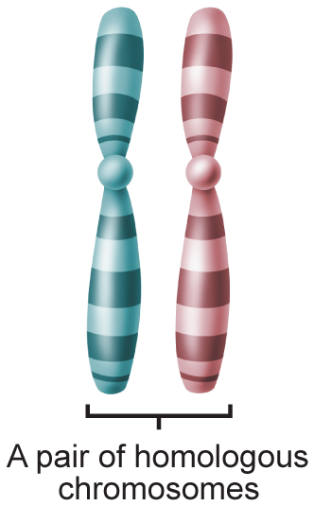
  - Haploid and Diploid Cells
- An organism produces gametes to maintain the same number of chromosomes from generation to generation.
- Human gametes contain 23 chromosomes.
- A cell with n chromosomes is called a haploid cell.
- A cell that contains 2n chromosomes is called a diploid cell.

  - Meiosis I
- The sexual life cycle in animals involves meiosis.
- Meiosis produces gametes.
- When gametes combine in fertilization, the number of chromosomes is restored.
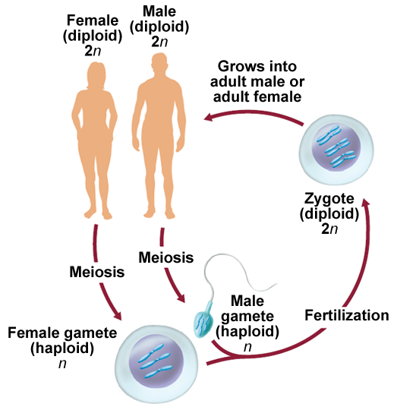

  - Stages of Meiosis I
- Reduces the chromosome number by half through the separation of homologous chromosomes
- Involves two consecutive cell divisions called meiosis I and meiosis II

Interphase
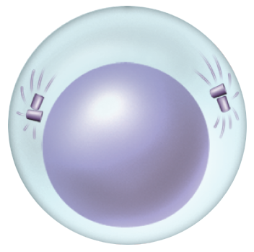

Prophase I
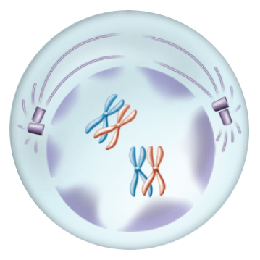

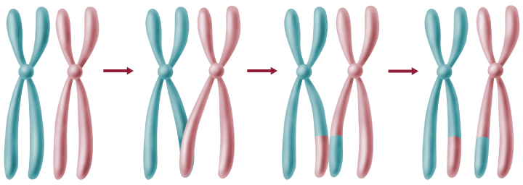

Metaphase 1
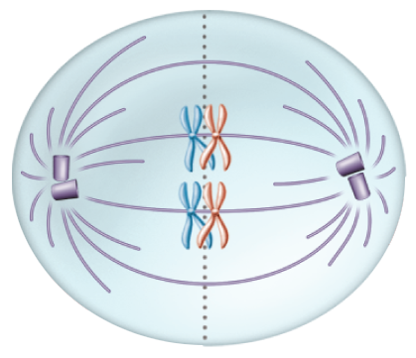

Anaphase 1
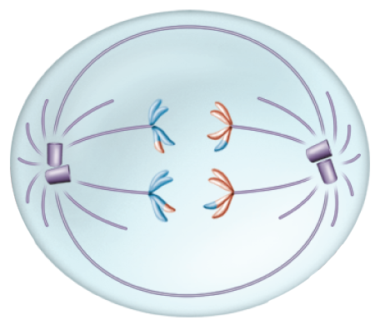

Telophase 1
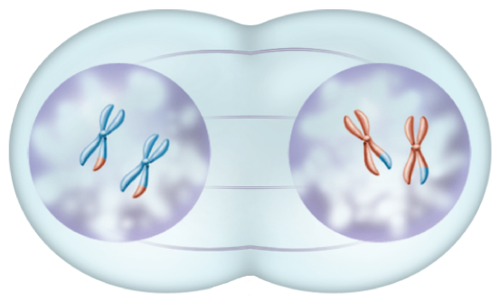

Prophase 2
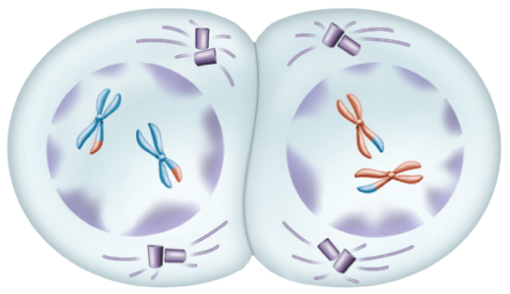
Metaphase 2
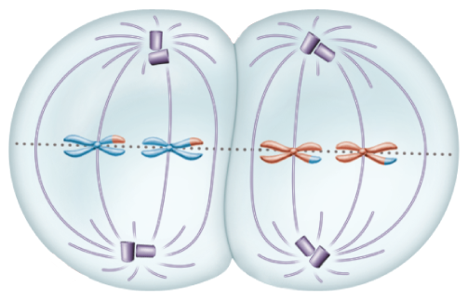
Anaphase 2
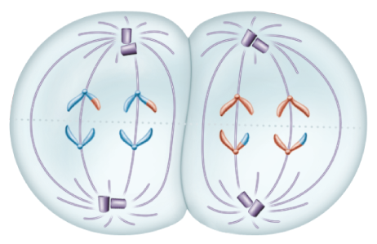

Telophase 2
