  - Honors Biology Chapter 22 Student Notes
Plant Cells
- Different kinds of plant cells make up plant tissues.
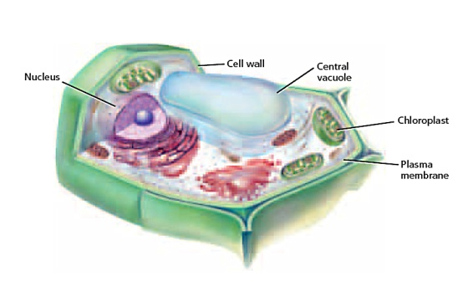
Parenchyma Cells
- Most flexible, thin-walled cells found throughout the plant are parenchyma cells.
- Functions:
  - Storage
  - Photosynthesis
  - Gas exchange
  - Protection
  - Tissue repair and replacement

Collenchyma Cells
- Plant cells that often are elongated and occur in long strands or cylinders that provide support for the surrounding cells are collenchyma cells.
- Functions:
- Support for surrounding tissues
- Provides flexibility for plant
- Tissue repair and replacement

Sclerenchyma Cells
- Plant cells that lack cytoplasm and other living components when they mature, leaving thick, rigid cell walls are called sclerenchyma cells.
- Functions:
  - Support
  - Transports materials

Plant Tissues
- A plant tissue can be composed of one or more types of cells.
- There are four different tissue types found in plants—meristematic, dermal, vascular, and ground.
Meristematic Tissue
Meristematic tissues make up meristems, or regions of rapidly dividing cells.

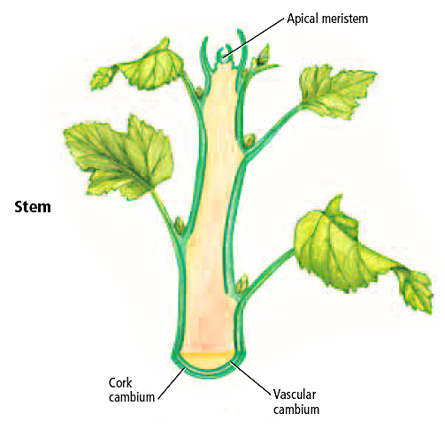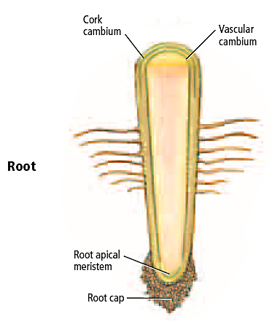

Dermal Tissue
- The layer of cells that makes up the outer covering on a plant is the epidermis.
- Most epidermal cells can create a fatty substance that forms the cuticle.
- The cuticle helps reduce water loss and prevent bacteria from entering the plant.

Stomata
- Small openings through which carbon dioxide, water, oxygen, and other gases pass
- The two cells that border a stoma are guard cells.
Root Hairs
- Increase a root’s surface area and enable the root to take in a greater volume of materials
Vascular Tissue
Xylem
  - Transports substances away from the roots
  - Composed of specialized cells called vessel elements
Phloem
  - Transports dissolved sugars and other organic compounds throughout the plant.
  - Sieve-tube member
    - Contain cytoplasm but lacks a nucleus
  - Companion cells
    - Help the sieve tube members
Ground Tissue
- Consist of parenchyma, collenchyma, and sclerenchyma cells
- Functions include photosynthesis, storage, and support

