  - Earth Science Chapter 9 Section 2Student Notes
Moving Water Carves a Path
- The first condition necessary for stream formation is an adequate supply of water.
- The region where water first accumulates to supply a stream is called the headwaters.
- It is common for a stream’s headwaters to be high in the mountains.
- A stream channel forms as the moving water carves a narrow pathway into the sediment
or rock.
- Stream banks, the ground bordering the stream
on each side, hold the moving water within the confines of the stream channel.
- Headward erosion is the process by which small streams erode away the rock or soil at the head of the stream.
- Sometimes, a stream erodes its way through the high area separating two drainage basins, joins another stream, and then draws away its water.
- This process is called stream capture,
or stream piracy.
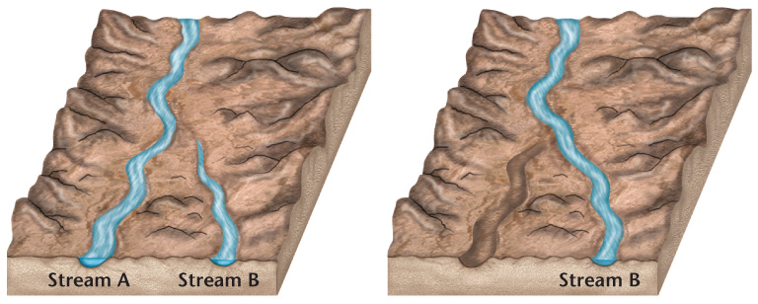
Formation of Stream Valleys
- As a stream actively erodes its path through the sediment or rock, a V-shaped channel develops.
- V-shaped channels have steep sides and sometimes form canyons or gorges.
- A stream continues to erode until it reaches its base level, the elevation at which it enters another stream or body of water.
- Over time, a V-shaped valley will be eroded into a broader valley that has gentle slopes.
Meandering Streams
- A stream’s slope, or gradient, decreases as it nears its base level, and as a result the channel gets wider.
- The decrease in gradient causes water to build up within the stream channel.
- Sometimes, the water begins to erode the sides of the channel in such a way that the overall path of the stream starts to bend or wind.
- A meander is a bend or curve in a stream channel caused by moving water.
- Water in the straight parts of a stream flows at different velocities, depending on the location of the water in the channel.
  - In a straight length of a stream, water in the center of the channel is flowing at the maximum velocity.
  - Water along the bottom and sides of the channel flows more slowly because it experiences friction as it moves against the land.
- The water moving along the outside of a meander curve experiences the greatest rate of flow within the meander.
  - The water that flows along this outside part of the curve continues to erode away the sides of the streambed, thus making the meander larger.
  - Along the inside of the meander, the water moves more slowly and deposition is dominant.
- It is common for a stream to cut off a meander and once again flow along a straighter path.
- The cut off meander becomes an oxbow lake, which eventually dries up.
- As a stream approaches its ultimate end point, the ocean, the streambed’s gradient flattens out and its channel becomes very wide.
- The mouth is the area of the stream that leads into the ocean or another large body of water.
Deposition of Sediments
- A stream’s velocity lessens and its sediment load drops when its gradient abruptly decreases.
- In dry regions, a stream’s gradient may suddenly decrease causing the stream to drop its sediment as a fan-shaped deposit called an alluvial fan.
- Alluvial fans are sloping depositional features formed at the bases of slopes and composed mostly of sand and gravel.
- Streams also lose velocity and the ability to carry sediment when they join larger bodies of quiet water.
- A delta is the triangular deposit, usually consisting of silt and clay particles, that forms where a stream enters a large body of water.
Rejuvenation
- Downcutting, or the wearing away of the streambed, stops when the stream reaches its base level.
- If the land over which the stream is flowing uplifts or if the base level lowers, the stream undergoes rejuvenation.
- During rejuvenation, a stream actively resumes the process of downcutting toward its base level.
- If rejuvenation occurs in an area where there are meanders, deep sided canyons are formed.

