  - Chapter 7 Section 2 Student Notes
Plasma Membrane
- Thin, flexible boundary between the cell and its environment
- Allows nutrients into the cell
- Allows waste to leave the cell
Selective Permeability
- The plasma membrane controls the movement of substances into and out of the cell.
Plasma Membrane
- Controls the amount of a substance entering the cell
- Controls the amount of a substance leaving the cell.
- The plasma membrane is composed of the phospholipid bilayer
- A phospholipid molecule is composed of a glycerol backbone, two fatty acid chains, and a phosphate group.
Fluid Mosaic Model
- The phospholipid bilayer allows other molecules to “float” in the membrane.
Other Components
- Proteins
- Cholesterol
- Carbohydrates
Proteins
- Transmit signals inside the cell
- Act as a support structure
- Provide pathways for substances to enter and leave
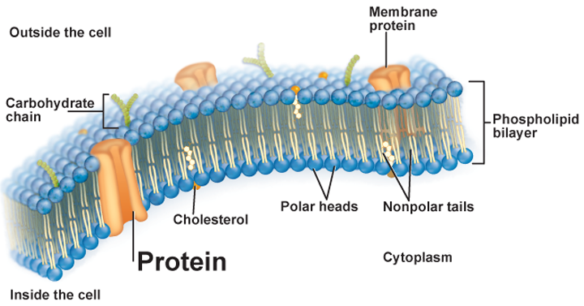

Cholesterol
- Prevents fatty acid tails from sticking together

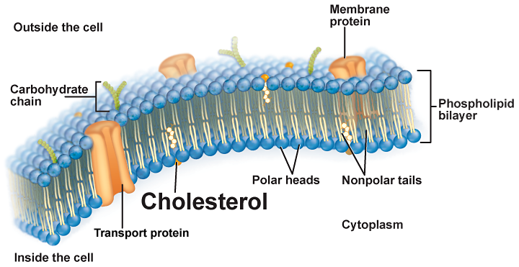

Carbohydrates
- Identify chemical signals

