Biology

Chapter 14 & 15 Study Guide
  - Chapter 14

How old is Earth?
How was the atmosphere made?
What are the gases in the atmosphere?
What gas is the most abundant in our atmosphere?
Categories of fossil types
Steps for the formation of fossils
Types of rocks
Fossil
Paleontologist
Relative dating
Law of superposition
Radiometric dating
Half-life
Geological time scale
Epoch
Period
Era
Eon
Precambrian
Paleozoic era
Mesozoic era
Plate tectonics
Cenozoic era
Spontaneous generation
Francesco Redi & his experiment
Theory of biogenesis
Louis Pasteur & his experiment
Stanley Miller and Harold Urey & their experiment
Method of making proteins
What were the first cells according to scientists?
What did cyanobacteria produce?
The Endosymbiont Theory
What was the first coding system?

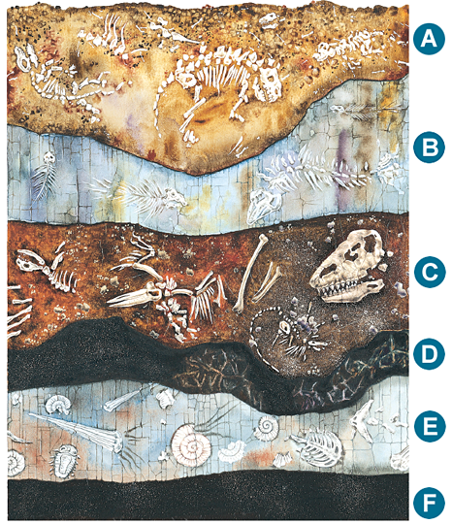

  - Chapter 15

HMS Beagle
Charles Darwin
Galapagos Island
Artificial selection
Natural selection
Evolution
The origin of species
Fossil record
Derived trait
Ancestral trait
Homologous structure
Vestigial structure
Analogous structure
Embryo
Biogeography
Fitness
Camouflage
Mimicry
Types of adaptation
Consequences of adaptation

